Corey Gaspar
2/8/2026
5-2 Assignment: Client-Side Authentication
I updated the header to include my name and created a sub header that reads “Corey Gaspar’s Client Server Authentication”.
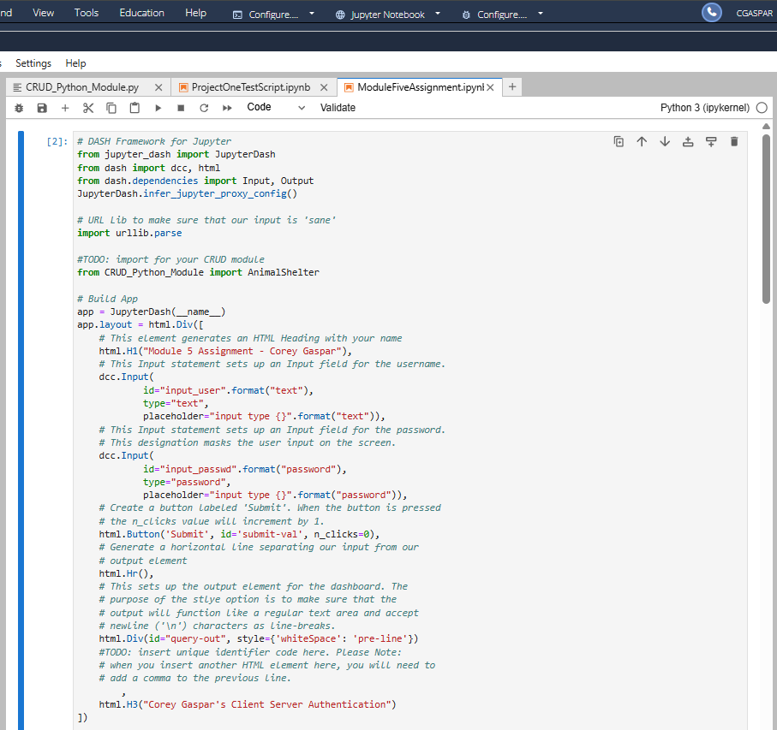

Next, I updated the file to instantiate the CRUD object that includes the username and password from the CRUD Python file. I also created an example query of the Dog animal type with the name of Lucy. I also created a format for each record that gets printed.
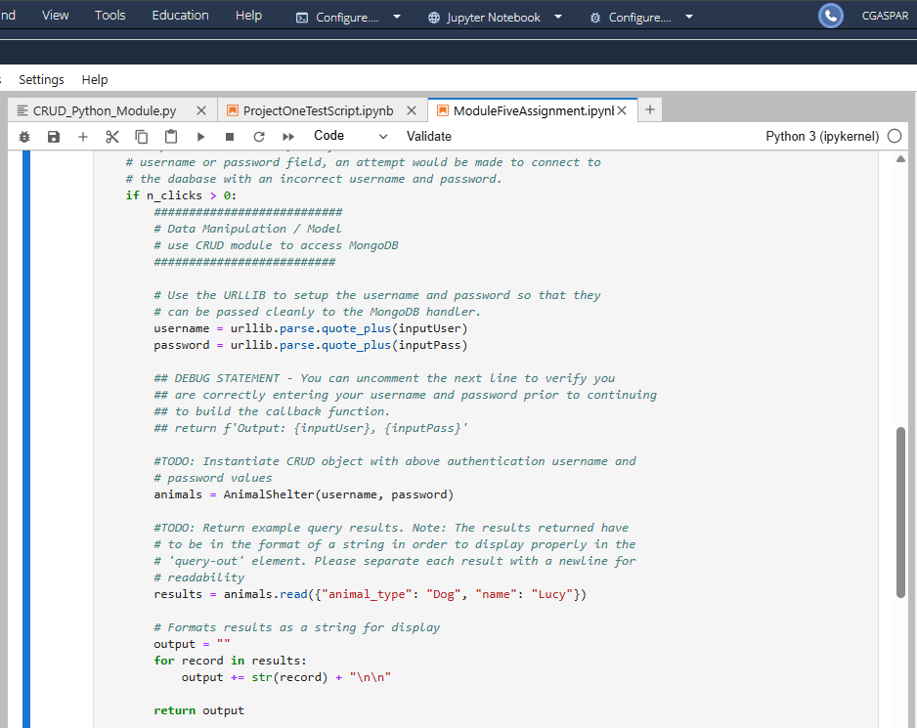

After running the code, I was able to access the dashboard username/password interface.
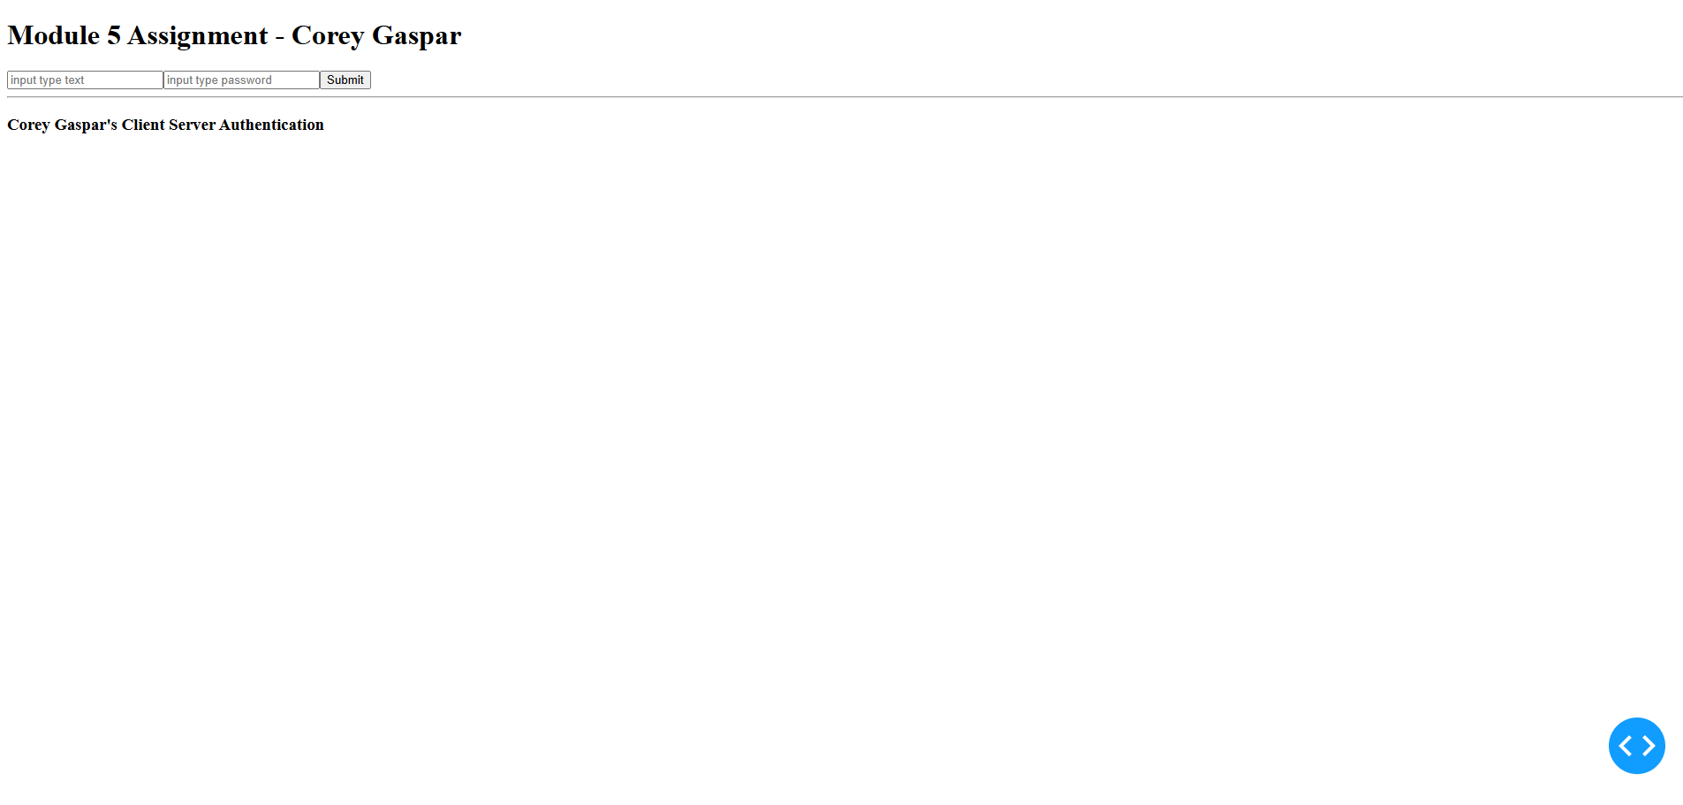
After entering the aacuser credentials in the username and password fields, the example query results were printed on screen.
